Name - ________________
Unit 1 Genocide
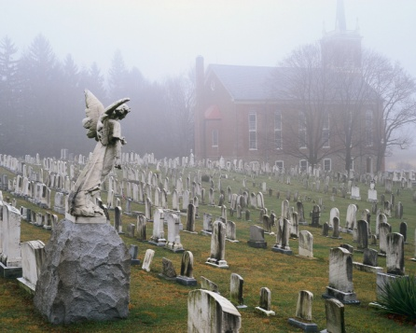

1. _____ 7. _____ 13. _____
2. _____ 8. _____
3. _____ 9. _____
4. _____ 10. _____
5. _____ 11. _____
6. _____ 12. _____
Extra Credit _____ Special Message to Instructor - ____________________
Total Points Unit 1 = 455 Grade on Unit 1 _____ X . 22 = _____
Research, Writing, and Reading:
- Lecture on citation. Notes need to be taken. 20 pts.
- Lecture and definition of genocide 20 pts.
- Chart or graph of the genocides of the 20th century. Cite material. 10 pts.
- Watch four videos on genocide and select one to share. Videos should be 5 to 10 minutes long. Citation all four videos and then write a one paragraph summary of the selected video. Cite the other three. Place the video on a shared site for all to view. 25 pts.
- Watch Hotel Rwanda and participate in the discussion of the film. 20 pts.
- Watch Ghosts of Rwanda and prepare study cards on each of the four sections. This can be viewed on blackboard or on line. 50 pts.
- Create a portfolio of 10 items or pages on a specific genocide. The portfolio may be in PowerPoint format, website, book, or video. 100 pts.
- Read the book The Sandcastle Girls by Chris Bohjalian. Follow the book review format below. 100 pts.
- Watch the video The Armenian Genocide with discussion to follow. 20 pts.
- Book discussion – This discussion includes participation and submitting comments and questions. Each student will need to participate in the discussion and have materials with them and interject at least five times. 20 pts.
- Search The New York Times, Time, or the Internet for two articles about genocide related issues and then underline in red the main issue of the article, underline in yellow major points given to prove the main idea or thesis, underline the counter argument if there is one. Then decide which of the articles is the better of the two. Write a paragraph describing your reasons. 50 pts.
- Create an argument that supports your idea for this unit. You need to create an essential question to answer. Write an outline to support your essay. 20 pts.
- Write an essay on genocide. You need to write an essential question to be answered and the essay should be correctly cited and fully supported with at least five sources. 100 pts.

Review format for the book:
- Take notes while reading – highlights, vocabulary, and book notes. All should be correctly labeled and printed in a 10 to 12 font.
- Create 10 essential questions raised by the characters in the book. Use book notes or create and print.
- Discuss the major characters in the book. At least three sentences about each character (physical, emotional, and importance to the plot). Print.
- Tweet, blog, Facebook, or utilize another social media with ten comments, quotes, or questions about the book. Print.
- Create an outline on the storyline of the book. Two pages in length.
- Create a thesis for the book, five reasons the author put forth to support this thesis, and a counter argument for the book.
- Print favorite quotes from book. Group and label quotes which were clever phrases from the author, which you found pivotal to the plot, which had informational importance, and quotes you just liked.
- Create a new ending to the story.

